Answers to H1 Chemistry Preliminary Examinations 2009

Paper 1

1 | B | 7 | C | 13 | B | 19 | B | 25 | B
2 | A | 8 | A | 14 | C | 20 | C | 26 | B
3 | D | 9 | C | 15 | A | 21 | B | 27 | C
4 | C | 10 | D | 16 | A | 22 | D | 28 | B
5 | D | 11 | D | 17 | D | 23 | B | 29 | A
6 | C | 12 | C | 18 | D | 24 | A | 30 | C

Paper 2

Section A

Answer all questions in this section in the spaces provided.

1 | (a) | The first six ionisation energies of three successive elements in a Periodic Table are given below:
   | Ionisation Energy in kJ mol⁻¹
  Element | 1st | 2nd | 3rd | 4th | 5th | 6th
  A | 786 | 1580 | 3230 | 4360 | 16100 | 19800
  B | 1060 | 1900 | 2920 | 4960 | 6270 | 21300
  C | 1000 | 2260 | 3390 | 4540 | 7000 | 8500
 |  | (i) |  | State and explain the Group of the Periodic Table which element B belongs to.
- Element B belongs to Group V.
- There is a big jump in I.E. between the 5th and 6th electron removed which implies that the 6th electron removed lies in an inner quantum shell, there are 5 valence electrons.
 |  | (ii) |  | Explain why the first ionisation energy of B is higher than each of A and C.
Element A (Group IV) and B (Group V):
- The nuclear charge of B is higher than that of A, while their screening effect is approximately the same.
- The increase in nuclear charge outweighs increase in screening effect. The valence electron to be removed from B is more strongly attracted by the nucleus, therefore it has a higher 1st I.E. than A.

Element B (Group V) and C (Group VI):
- The valence electron to be removed from C is one of the paried electrons in the p orbital. It experiences inter-electronic repulsion, therefore less energy is required to remove it.
 |  |  |  | [5]
 | (b) | - Write a balanced equation for the preparation of 1-bromopentane from pentan-1-ol.  •  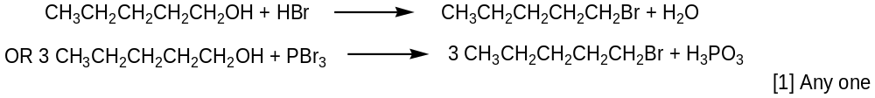
 |  | (ii) |  |  | If this preparation gives a yield of 60%, what mass of pentan-1-ol is required to produce 15.0 g of 1-bromopentane?
 |  | •  •  • |  |  | % yield = 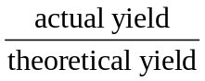  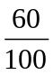= 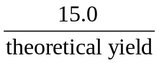  Therefore, theoretical yield = 15.0 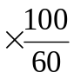= 25.0 g  No. of moles of pentan-1-ol  = No. of moles of 1-bromopentane  = 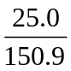  = 0.166 mol  Mass of pentan-1-ol required  = 0.166 88  = 14.6 g
 |  |  | [4]
 |  |  | [Total: 9]
2 | (a) | In the laboratory, the presence of SO₂ can be confirmed using an acidified solution of K₂Cr₂O₇. The SO₂ is oxidised to form SO₄²⁻ by K₂Cr₂O_{7.}
 |  | (i) |  | State the oxidation state of S in SO₂ and SO₄²⁻ and write an ion-electron half equation for the oxidation of SO₂ to SO₄²⁻.
- S in SO₂: +4 and S in SO₄²⁻: +6
- SO₂ + 2H₂O → SO₄²⁻ + 4H⁺ + 2e
 |  | (ii) |  | Write a balanced equation for the above reaction.
 |  |  |  | - 3SO₂ + Cr₂O₇²⁻ + 2H⁺ → 3SO₄²⁻ + 2Cr³⁺ + H₂O
 |  |  |  | [3]
 | (b) | 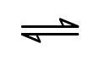  SO₂ can be converted into SO₃ and it involves the following equilibrium reaction:  2SO₂(g) + O₂(g) 2SO₃(g) ΔH = -196 kJ mol⁻¹
- When 1.5 mol of SO₂ is mixed with 0.5 mol of O₂ in 650 cm³ closed vessel at 450 ºC, it was found that 94 % of O₂ reacted. Calculate the equilibrium concentration of SO₂, O₂ and SO₃.
2SO₂(g) + O₂(g) 2SO₃(g)

Initial moles/mol 1.5 0.5 0

Change in moles -2(0.47) -0.47 +2(0.47)

Eqm moles/mol 0.56 0.03 0.94

- [SO₂] = (0.56/650 x 1000) = 0.862 mol dm⁻³
- [O₂] = (0.03/650 x 1000) = 0.0462 mol dm⁻³
- [SO₃] = (0.94/650 x 1000) = 1.45 mol dm⁻³

- Hence calculate K_{c} for the reaction, stating its units.
- K_{c} = (1.45²)/(0.862²)(0.0462) = 61.2
- mol⁻¹dm³ [5]

- Explain the effect on the position of equilibrium and K_{c} value when the total volume of the system was increased.
- When the total volume of the system was increased, the pressure of the system decreases. By Le Chatelier’s Principle, the system will try to counteract the decrease in pressure by producing more number of moles of gases. The backward reaction is favoured and the position of equilibrium shifts left.
- K_{c} remains unchanged.
- Explain why a temperature of 450 ºC was chosen as opposed to using much higher or lower temperatures.
- By Le Chatelier’s Principle, a lower temperature is preferred as the equilibrium position will shift right towards the exothermic reaction.
- However, if the temperature is too low, the rate of the reaction will be very slow. Hence a compromise of 450°C is used to achieve a reasonable yield at a reasonable rate.

[4]
 |  |  | [Total: 12]
3 | (a) | For the reaction scheme below, give the reagents and conditions for Step I and Step II in the space provided, and draw the structural formula of Compound A and B in the boxes provided.  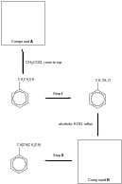  Compound A:  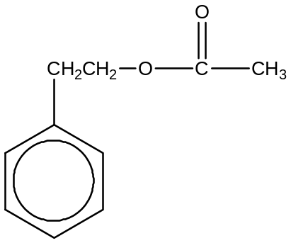  Compound B:  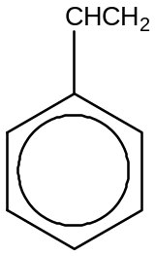  Step I:  Reagents: …PCl₅(s)……...…………………………………………………………………….  Conditions: …room temperature or cold……………………………………………...………  Step II:  Reagents: …alkaline KMNO₄ or dilute acidic KMNO₄ ……………………………………….  Conditions: …cold………………...…..……………………………………………………….  [6]
 | (b) | Compound A undergoes hydrolysis with dilute H₂SO₄(aq) under reflux to give two compounds. Give the structural formula of the two compounds formed and describe a chemical test to distinguish between the two compounds.
• • 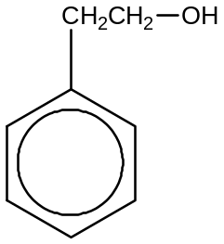 and 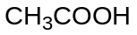

• Add NaCO₃ to both compounds. The one that give a colourless efferverscence of CO₂ gas would indicate CH₃COOH present. No efferverscence observed for

[3]
 | (c) |  |  | Explain why pentane (Mr = 44), is a gas as under standard conditions and is insoluble in water whereas ethanol (Mr = 46) is a liquid and is soluble in water.
 |  |  |  | - Both propane and ethanol are simple molecular molecules. Propane molecules are non-polar and have only weaker induced dipole-induced dipole attraction (or VDW’s forces).
 |  |  |  | - Ethanol molecules experience hydrogen bonding as their intermolecular forces of attraction. Hence more energy is required to overcome the stronger H-bonding between ethanol molecules and it exists as a liquid while propane exists as a gas.
 |  |  |  | - Propane is insoluble in water as the interaction(van der Waals forces of attraction) between propane molecules and water molecules is too weak to overcome the strong intermolecular attraction, hydrogen bonding, between the water molecules.
- Ethanol is soluble in water as the hydrogen bonding between ethanol and water molecules is comparable to the attraction(hydrogen bonding) between the water molecules.
(any 3 points)
[3]
[Total: 12]
4 | (a) | This question is about chlorine and its compounds.  The melting point of POCl₃ is 1.25 ºC whereas the melting point of PCl₅ is 166.8 ºC.
 |  | (i) |  | Name and draw diagrams to illustrate the shapes of POCl₃ and PCl₅.  ●●  P  Cl  O  Cl  Cl  P  Cl  Cl  Cl  Cl  Cl  POCl₃  Tetrahedral  PCl₅  Trigonal bipyramidal
 |  | (ii) |  | Explain, in terms of structure and bonding, why PCl₅ has a higher melting point.
- POCl₃ and PCl₅ both are simple discrete molecules with weak van der Waals’ forces of attraction between the molecules (or POCl₃ has permanent-dipole-permanent-dipole interactions while PCl₅ has induced-dipole-induced-dipole interactions between molecules)
- PCl₅ has a much larger M_{r} than POCl₃, and therefore a larger electron cloud that is more easily distorted, giving rise to larger partial charges, resulting in stronger van der Waals’ forces
 |  |  |  | [4]
 | (b) | Suggest a synthetic route for the synthesis of:  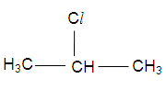  from  2-chloropropane  propan-1-ol
● HCl, room temperature
● Excess concentrated H₂SO₄, 180 ºC

[3]
● H₃C-CH=CH₂
[Total: 7]

Section B

5 | (a) | (i) |  |  | - pH is negative logarithm to base 10 of the hydrogen ion concentration.
 |  | (ii) |  |  | - [OH⁻] = 0.1 mol dm⁻³  pH = 14 – (-lg(0.1)) = 13.0
 |  | (iii) |  |  | - CH₃COOH + NaOH → CH₃COO⁻Na⁺ + H₂O
 |  | (iv) |  |  | - Number of moles of CH₃COOH = 20/1000 x 0.250 = 5.00 x 10⁻³ mol  Volume of NaOH required = (5.00 x 10⁻³/ 0.1) x 1000 = 50.0 cm³
 |  | (v) |  |  | - Number of moles of salt formed = 5.00 x 10⁻³ mol  - Concentration of salt = 5.00 x 10⁻³/ (70/1000) = 0.0714 mol dm⁻³
 |  | (vi) |  |  | - Phenolphthalein  - The value of pK_{In} is close to the value of the pH of the solution at the equivalence point and the working range of indicator is on the vertical part of the pH curve.  - Colourless to pink
 |  | (vii) |  |  | (I)  - A buffer is a solution which resists changes in pH on addition of a small amount of acid or a base.
(II) CH₃CH₂CO₂H CH₃CH₂CO₂⁻ + H⁺
CH₃CH₂CO₂⁻Na⁺ CH₃CH₂CO₂⁻ + Na⁺

- Adding small amount of OH⁻,
CH₃CH₂CO₂H + OH⁻ CH₃CH₂CO₂⁻ + H₂O
OH⁻ is neutralised by the weak acid. Negligible change in pH

- Adding small amount of H⁺
CH₃CH₂CO₂⁻ + H⁺ CH₃CH₂CO₂H
The conjugate base, CH₃CH₂CO₂⁻ mainly from salt reacts with H⁺ to form CH₃CH₂CO₂H. Negligible change in pH as H⁺ ions are removed.

 |  | (viii) |  |  | - HCl is a strong acid which dissociates completely in water (or show equation)  HCl → H⁺ + Cl⁻  - However, CH₃COOH is a weak acid which dissociates partially in water (or show equation). Hence, the concentration of [H⁺] from CH₃COOH is different and the pH will not be the same.  CH₃COOH CH₃COO⁻ + H⁺
 |  |  |  |  | [14]
 | (b) | (i) |  |  | - The standard enthalpy change of neutralisation, ΔH_{n}^{ө}, is the enthalpy change when an acid and a base react under infinitely dilute conditions to form one mole of water at 298 K and 1 atm.
 |  | (ii) |  |  | - Number of moles of CH₃COOH = 40/1000x 0.875 = 0.0350 mol  Number of moles of NaOH = 40/1000 x 1.5 = 0.0600 mol  Number of moles of water formed = 0.0350 mol  - Heat evolved = (40 + 40) x 4.18 x (31.3 – 25.8) = 1840 J  - Enthalpy change of neutralisation  = -1840/0.0350  = -52.6 kJ mol⁻¹
 |  | (iii) |  |  | - The enthalpy change of neutralisation involving CH₃COOH and NaOH is less exothermic than HCl and NaOH.  - CH₃COOH is a weak acid, some of the energy evolved from the neutralisation process is used to further dissociate CH₃COOH.  [6]
 |  |  | [Total: 20]
6 | (a) | - Hydrogen gas in the presence of Pd or Pt at room temperature OR hydrogen gas in presence of Ni at elevated temperature and pressure  - Electrophilic Addition  [2]
 | (b) | (i)  [Compound X]/ mol dm⁻³ |  | ••  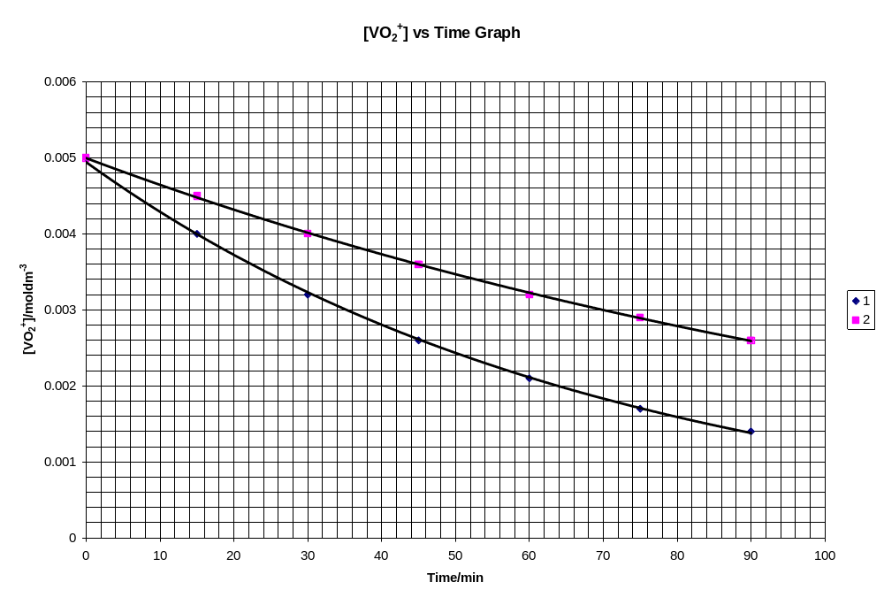  [Compound X] VS Time
 |  | (ii) |  | From the graph (experiment 1):  1st t = 48.5 min  2nd t = 48.5 min  3rd t = 49.5 min  - Since the 3 half-lives are constant, the order of reaction with respect to Compound X is 1.  Initial rate for Expt 1  = 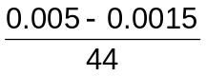  = 7.95 × 10⁻⁵ mol dm⁻³ min⁻¹  Initial rate for Expt 2  = 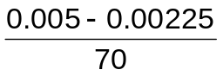  = 3.93 × 10⁻⁵ mol dm⁻³ min⁻¹  - When [H⁺] is halved, the initial rate is also halved. The order of reaction with respect to H⁺ is 1.  - Hence the rate equation:  rate = k [Compound X] [H⁺]
 |  | (iii) |  | rate = k [Compound X] [H⁺]  - 7.95 x 10⁻⁵ = k x 0.0050 x 0.10  - k = 0.159 mol⁻¹ dm³ min⁻¹  [7]
 | (c) | - An increase in temperature increases the average kinetic energy of the reacting molecules. This results in an increase in the frequency of collision between the molecules.  - Colliding molecules must possess a minimum energy, known as activation energy, E_{a}, in order for the reaction to take place.  - The fraction of molecules having energy ≥ E_{a} is significantly increased when the temperature is increased. Hence, this increases the frequency of effective collisions leading to an increase in reaction rate.  activation energy, E_{a}  Number of molecules  T₂  T₁  No. of reactant molecules having energy ≥ E_{a} at temperature T₂  T₂ > T₁  No. of reactant molecules having energy ≥ E_{a} at temperature T₁  •  .  Energy  [4]
 | (d) | - No. of moles of HCl = No. of moles of excess NaOH  = 0.02 x 0.05 = 0.00100 mol  - No. of moles of NaOH reacted = No. of moles of Compound X  = (0.03 x 0.1) – 0.001  = 0.00200 mol  - Concentration of Compound X = 0.002 / 0.02  = 0.100 mol dm⁻³  [3]
 | (e) | - Similar to aluminium, beryllium has high charge density and high polarising power to distort the electron cloud on the chloride introducing covalent character to BeCl₂.  - BeCl₂ has a simple molecular structure.  - Boiling of BeCl₂ would overcome the weak van der Waals forces of induced dipole-induced dipole attraction between the discrete molecules, thus it has low boiling point (higher volatility)  - MgCl₂ has a giant ionic structure. Boiling would involve the breaking of strong electrostatic forces of attraction between oppositely charged ions, thus it has a high boiling point (lower volatility)  [4]
 |  |  | [Total: 20]
7 | (a) | - Sodium is a metal and it is a good conductor because of the mobile delocalised valence electrons.  - Silicon is a semiconductor with low electrical conductivity under normal condition as the electrons within the covalent bonds are held much more tightly (limited free electrons and “holes”). Conductivity increases with an increase in temperature for the electrons are excited to higher energy levels.  - Phosphorus is a non-metal and non-conductor as all valence electrons are involved in covalent bonding and hence no mobile electrons are present.  [3]
 | (b) | (i) |  | ••• NaCl, SiCl₄, and PCl₃ or PCl₅.
 |  | (ii) |  | - NaCl dissolves in water without further reaction to give a neutral solution,  NaCl(s) → Na⁺(aq) + Cl⁻(aq)  Both SiCl₄ and PCl₅ undergo hydrolysis to give strongly acidic solutions.  - SiCl₄ + 2H₂O → SiO₂ + 4HCl  - PCl₅ + 4H₂O → H₃PO₄ + 5HCl OR PCl₃ + 3H₂O → H₃PO₃ + 3HCl
 |  | (iii) |  | •  Si  Cl  Cl  Cl  ×  ×  ×  ×  ×  ×  ×  ×  ×  ×  ×  ×  ×  ×  ×  ×  ×  ×  ×  ×  ×  •  •  •  Cl  ×  ×  ×  ×  ×  •  ×  ×  • Shape: tetrahedral  [8]
 | (c) | - Compound P is acidic as it is readily soluble in aqueous NaOH → contain –COOH group  - Compound Q gives a yellow ppt, CHI₃, with aq I₂ → contains  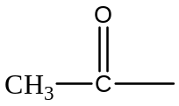 or 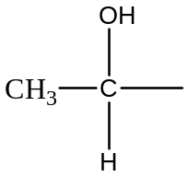  - Compound R exhibit cis-trans isomerism → contains alkene functional group  - Compound R :  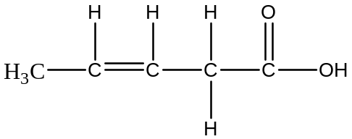  Compound Q undergoes dehydration to give R.  - Compound Q:  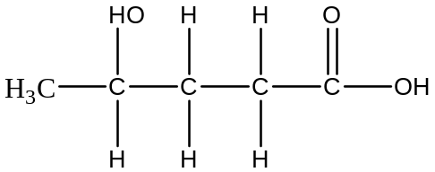  - Compound R undergoes oxidation with acidified KMNO₄ to give compounds S and T.  - Compound S contains 2 –COOH grps as 1 mole of S reacts with NaCO₃ to give 2 moles of CO₂.  • Compound S:  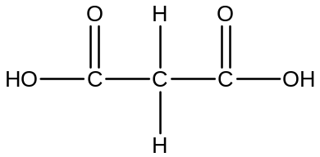  • Compound T:  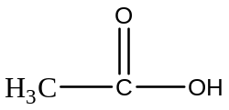  - Compound P undergoes nucleophilic substitution with NaOH followed by acidification to give compound Q → P contains halogenoalkane.  • Compound P:  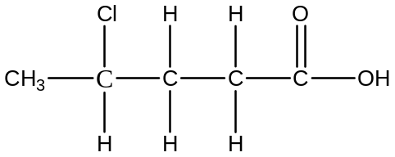 (max: 9m)  [9]
 |  |  | [Total: 20]

